ODYSSEY CORPORATE WEBSITE

***USER GUIDE DOCUMENT – DRUPAL CMS***

Table of Contents

Login 4

Update Profile/Change Password 4

Creating Contents 5

Home/Landing Page (Business/Personal) 5

Banner 5

Quick Links 7

Product Section 8

Customer Promises 9

News and Articles 10

Mobile Banking 11

Awareness and Twitter Feed 12

Trusted Providers 12

Awareness 13

Title 14

Description 14

Image/Video 14

Download or Read more Links 15

Product Suite Pages 15

Current Account Suite Pages (Business Current / Personal Current) 15

Savings Account Suite Page 22

Finance Suit Page(Property Finance/Business Finance) 26

Product Pages 33

Banner 34

Header Links 34

Components 34

About Us Landing Page 41

News & Articles 47

About Us Pages 52

Banner 53

Content 53

Authenticator App Pages 53

Title 53

Banner 53

Quick Links 53

Content 54

Trusted Providers 54

Customer Feedback 57

FAQs 58

Document Library 60

Quick Links 60

Regional Office 62

Team Members 62

Team 63

Conditions 64

Footer Section 64

First Block-Menu Links 66

Second Block – Description 67

Third Block – Link 67

Creating Users 68

# Login

* 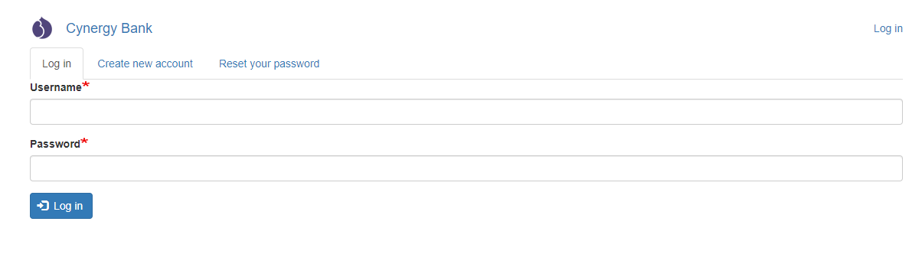Look for the login button on the screen or enter “site name/user/login” to get the login form here for example <http://cms.dev.cynfusion.net/user/login>
* enter your credentials and login to the site for creating and managing the contents.

# Update Profile/Change Password

* Once logged in one can change the password by editing the profile, click on the username shown on top it will give the edit profile option

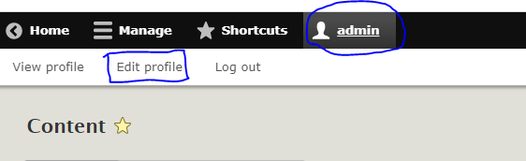

* You will get the profile edit form where you can update your details:

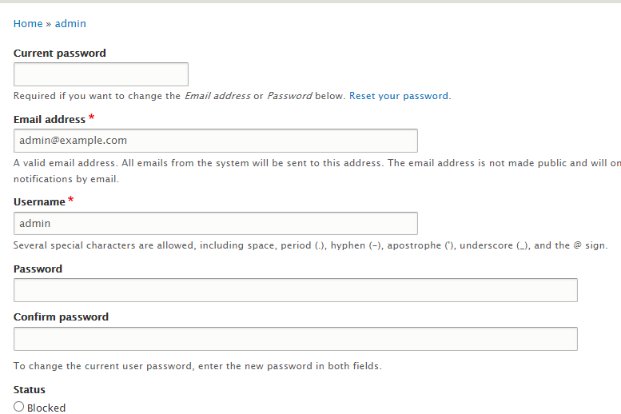

# Creating Contents

## Home/Landing Page (Business/Personal)

* Once logged in click on “**Content**” it will land you to the content listing page where you can see an option to **“Add content”**

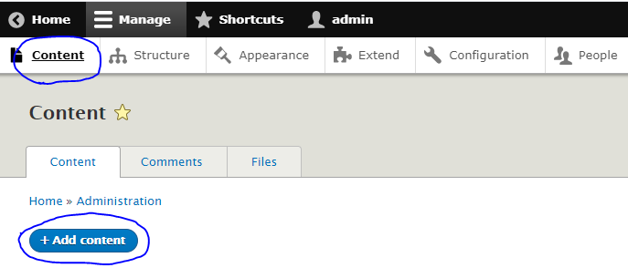

* Add content option will take you to the list of content types page where you have to select the type of page you want to create, here for landing pages we’ll select **“Home/Landing Page”**

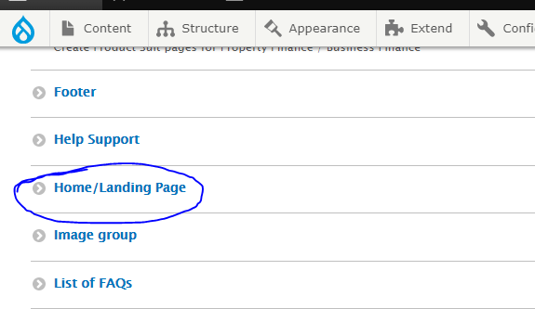

* On the content creation form you will have to fill all the details section by section

### Banner

* Image 1 below is from the design page; how it should look and image 2 is the banner creation section on the form.

Img1

Img2

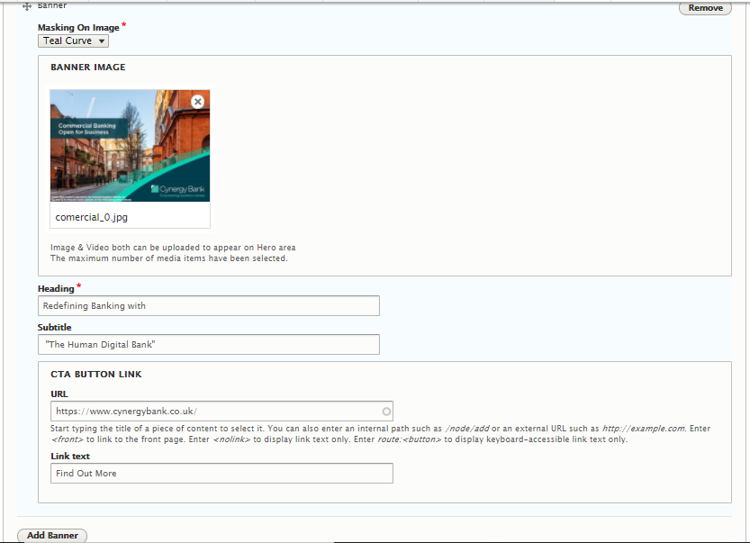

* The Masking option is for the overlay design on top of the image, you will have different masking options to select.
* Next field is for media you can upload a new image/video or select from existing media library. Remote video path also can be given.

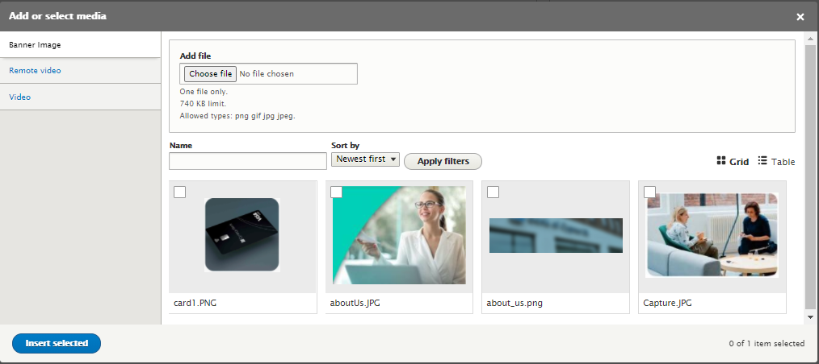

* Heading and Subtitle fields are for the text which should appear on the banner.
* For the Button on the banner we have **“CTA Button link”** field, you can enter the text on the button and the link it should navigate to.
* You can add multiple banners by clicking the **“Add Banner”** button at the end of the section

### Quick Links

* Image 1 below is from the **design page**; how it should look and image 2 is the **“quick links”** section on the form.

Image1

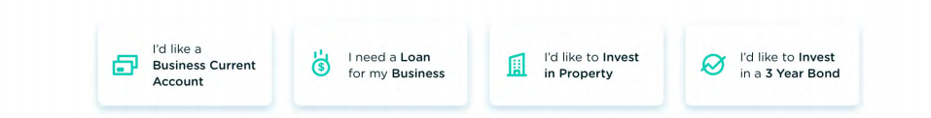

Image2

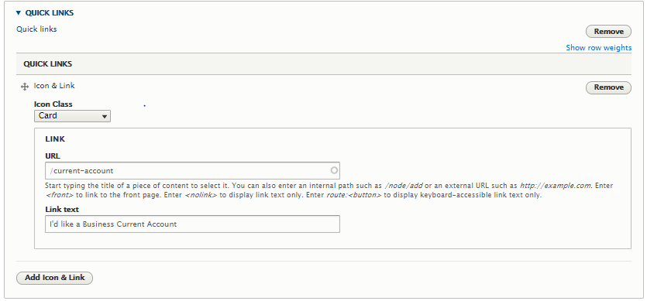

* The icon class need to be selected based on which the icons will appear on the frontend.
* Link text and link URL field for the quick links section , for each card you have to enter these 3 details.
* Click on “Add Icon & Link” button to add one more card which will repeat the above fields.

### Product Section

* Image 1 below is from the **design page**; how it should look and image 2 is the **“product”** section on the form.

Img1

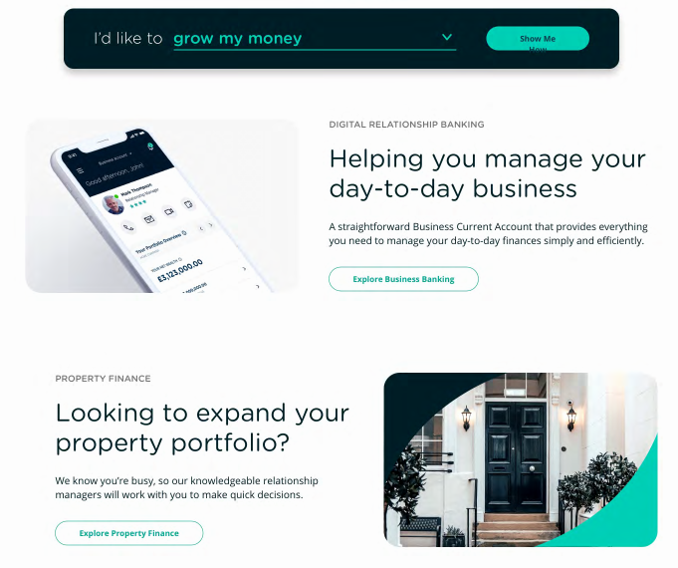

Img2

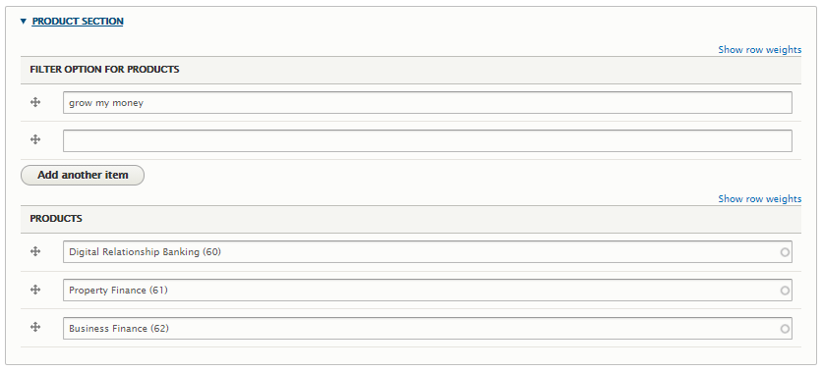

* Filter option for the products to be entered e.g. Grow my money, to add more options click on the button **“Add another item”**
* Product which are already created here can be referenced on the product field, start typing the title of the content will auto populate to select.
* Product suite pages also can be referenced which are created here.

### Customer Promises

* Image 1 below is from the **design page**; how it should look and image 2 is the **“product”** section on the form.

Img1

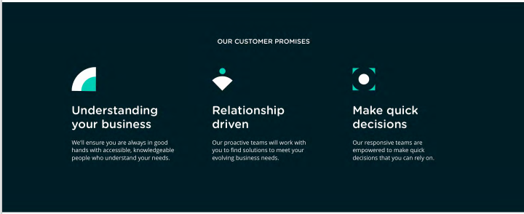

Img2

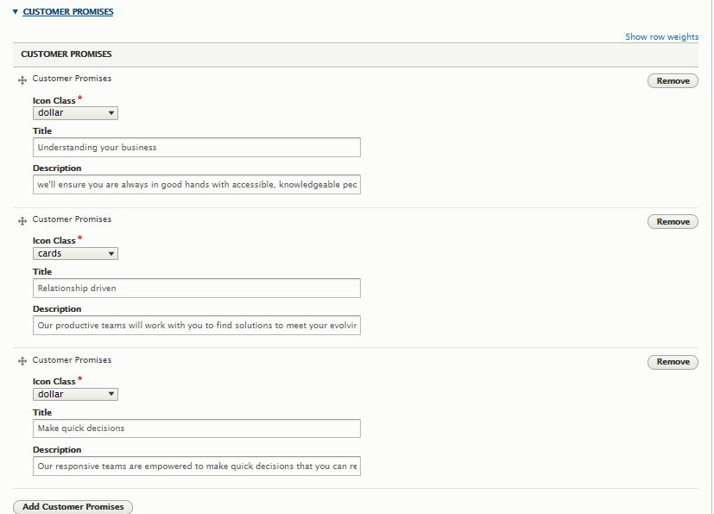

* The icon class need to be selected from the list of options for the icons to appear on the frontend.
* The title field for the customer promise and description to be added.
* Multiple customer promises can be added by clicking on the button **“Add Customer Promises”**

### News and Articles

The image below shows the design how the news and articles section on the front end.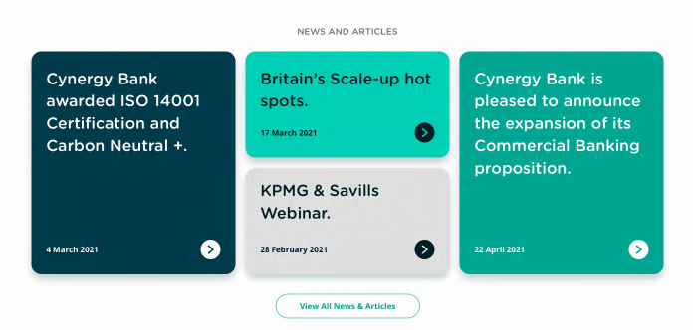

* The news and articles which are added here with the option ***“Featured on Home Page”*** selected will appear here

### Mobile Banking

* Image 1 below is from the **design page**; how it should look and image 2 is the **“Mobile Banking”** section on the form.

Img1: 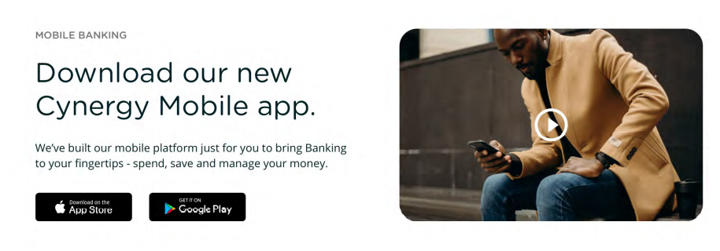

Img2: 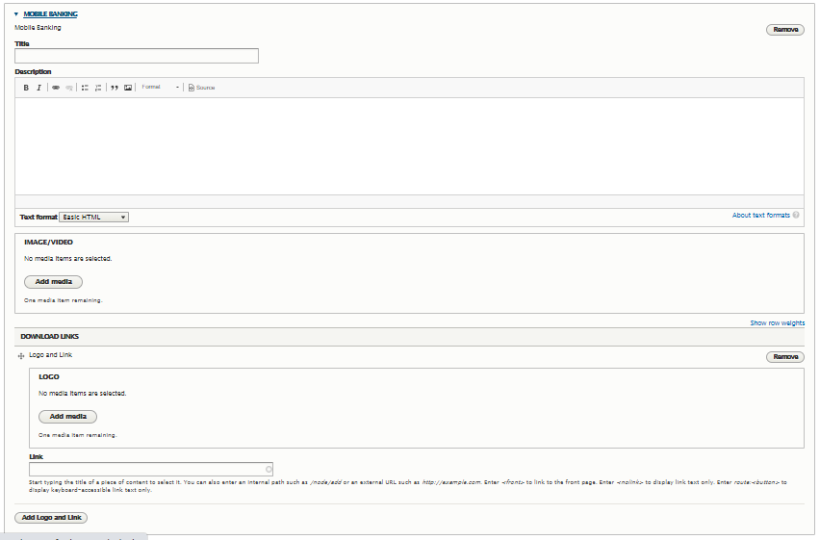

* **Title** and **Description** fields are the text fields respective text should go in there.
* You can upload image or video file or give path to remote video URL in the **Image/Video** field which should appear on the mobile banking section.
* The Appstore and Play store links and respective logo images can be added in the Download links field section.

### Awareness and Twitter Feed

* Image 1 below is from the **design page**; how it should look and image 2 is the **“Awareness”** section on the form.

Img1: 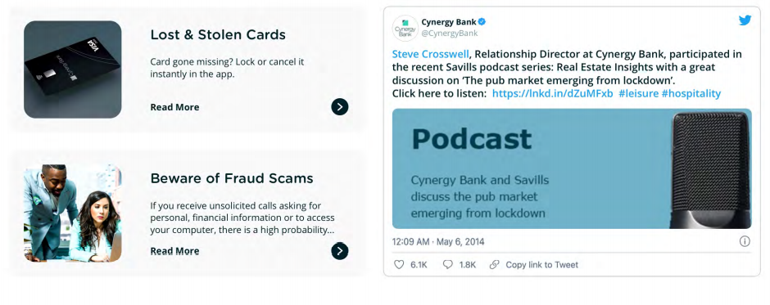

Img2: 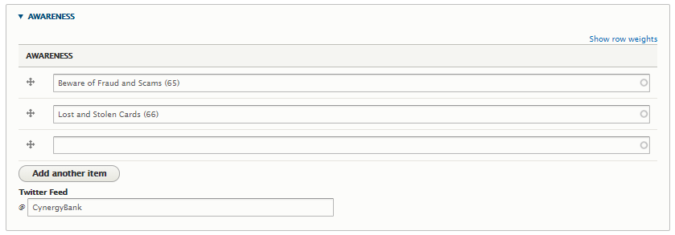

* The **Awareness** contents created here can be referenced, start typing the title of the content will auto populate to select.
* Twitter handle can be specified on the **“Twitter Feed”** and the feeds will be handled by front end.

### Trusted Providers

* Image 1 below is from the **design page**; how it should look and image 2 is the **“Trusted Provider”** section on the form.

Img1: 

Img2: 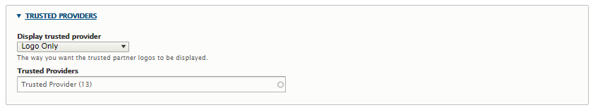

* We can have different style for displaying the “trusted providers” here in design we need “Logo Only” that can be selected from the options on the field “**Display trusted provider**”
* The trusted provider content created here can be referenced in the field **“Trusted Providers”**

Once all the details are filled click on the save button at the bottom of the screen, if you are an admin you can publish it directly else it will be saved as draft version which an admin can review and publish/archive later.

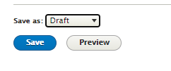

## Awareness

* Once logged in click on “**Content**” it will land you to the content listing page where you can see an option to **“Add content”**



* Add content option will take you to the list of content types page where you have to select the type of page you want to create, here for Awareness contents we’ll select **“Awareness”**

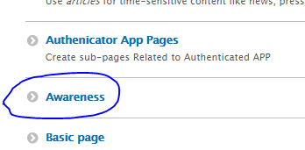

* On the content creation form you will have to fill all the details section by section

### Title

* It’s the text field for the **“Title”** of the content

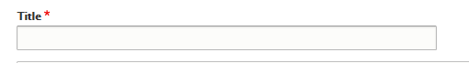

### Description

* It’s the text field which contains the details of the content

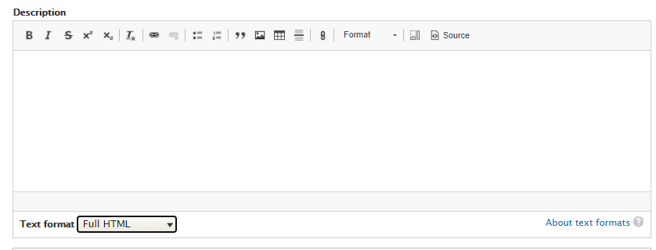

### Image/Video

* Using this field you can upload new image or videos/select existing from media library or for remote videos just provide the video URL

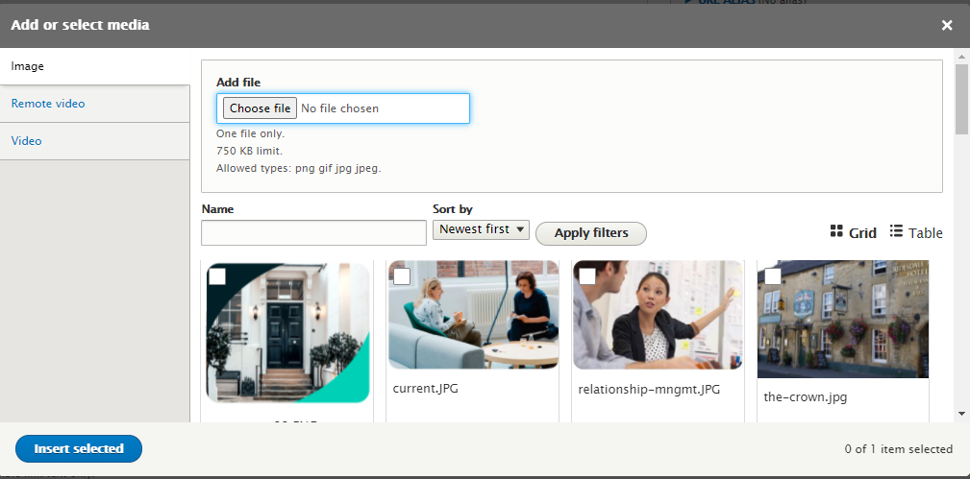

### Download or Read more Links

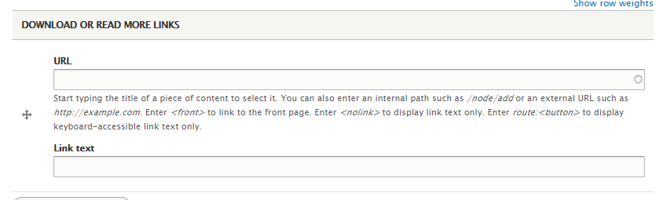

* This is a Link field where you can provide the Link text URL for any downloadable doc or other page URL.
* Once all the details are filled click on the save button at the bottom of the screen, if you are an admin you can publish it directly else it will be saved as draft version which an admin can review and publish/archive later.



## Product Suite Pages

### Current Account Suite Pages (Business Current / Personal Current)

* Once logged in click on “**Content**” it will land you to the content listing page where you can see an option to **“Add content”**



* Add content option will take you to the list of content types page where you have to select the type of page you want to create, here for landing pages we’ll select **“Current Account Suite Pages”**

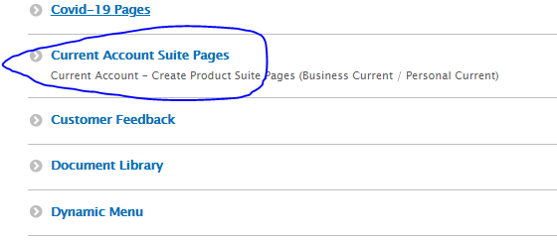

* On the content creation form you will have to fill all the details section by section

#### Banner:

* Banner section is same as home page, refer here

#### Highlights:

* Image 1 below is from the **design page**; how it should look and image 2 is the **“Highlights”** section on the form.

Img1: 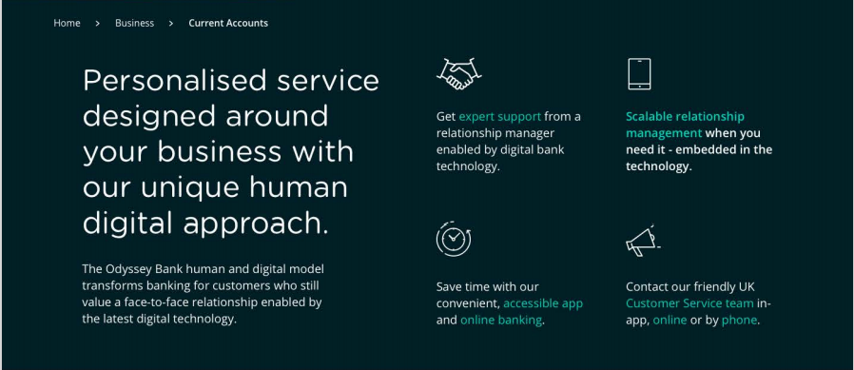

Img2: 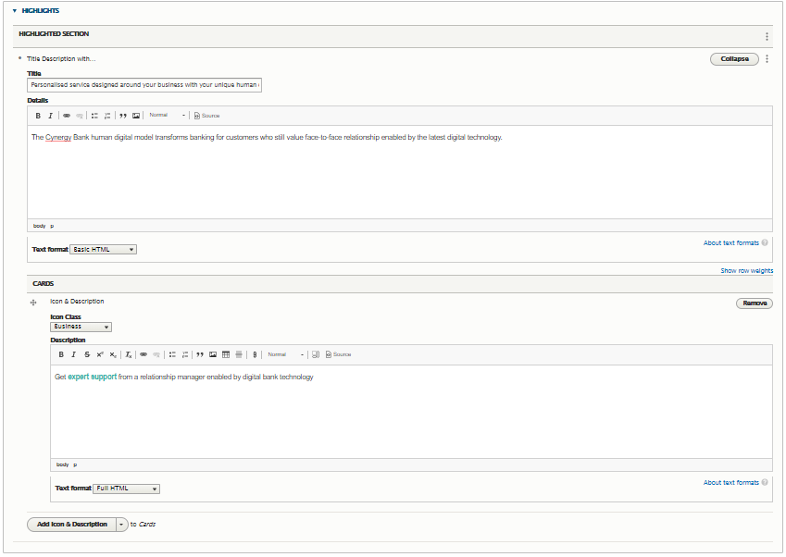

* **“Title”** and **“Details”** fields are the text fields which is shown on left half of the design page (Img1)
* On design screen you can see 4 Cards with icon image & some text those can be added individually using the **“Cards”** field.
* To add new card click on the button **“Add Icon & Description”** button it will populate the same set of fields i.e. **“Icon Class”** & **“Description”**

#### Compare Accounts:

* Image 1 below is from the **design page**; how it should look and image 2 is the **“Highlights”** section on the form.

Img1: 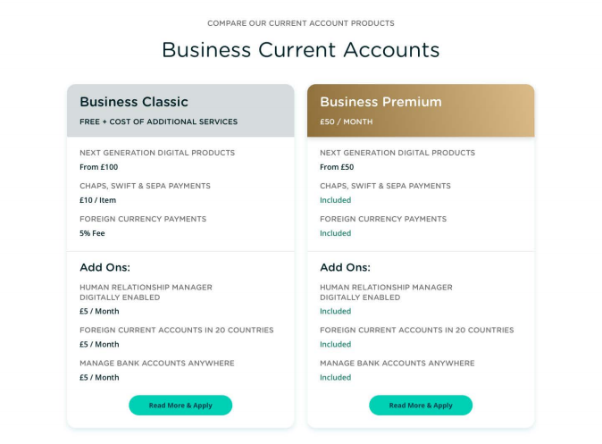

Img2: 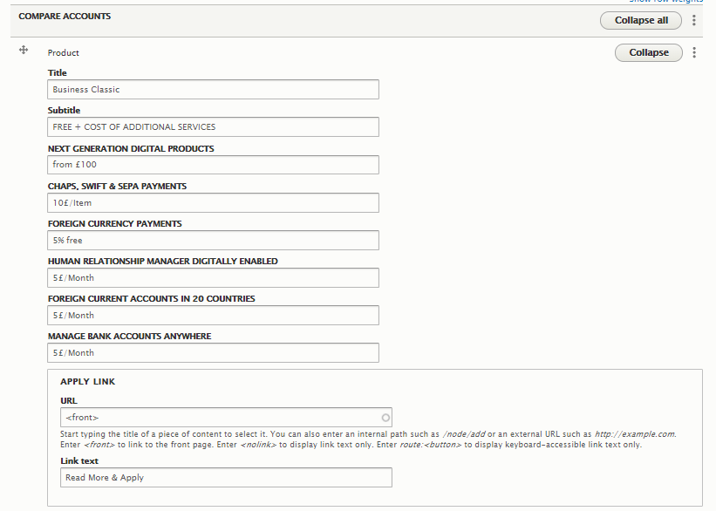

* In this section we are comparing 2 products, details of each can be filled in individually.
* All are the text fields except the **“Apply Link”** link text and URL to be specified here, this URL will take you to the landing page of that specific product.

#### Components:

* We can have different types of component in this field as shown below, according to the design the component type can be selected

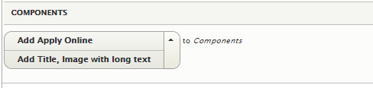

* For “Benefits” section on the design page(**Img1** below) will select the component type as **“Title, Image with long text”** from the list it will populate with the fields for the same (**Img2** below)

Img1:

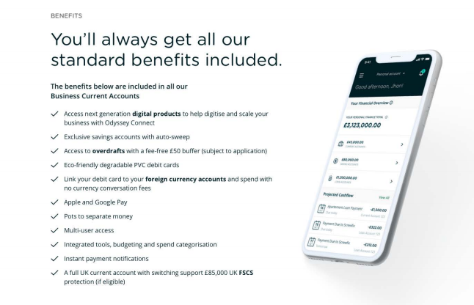

Img2: 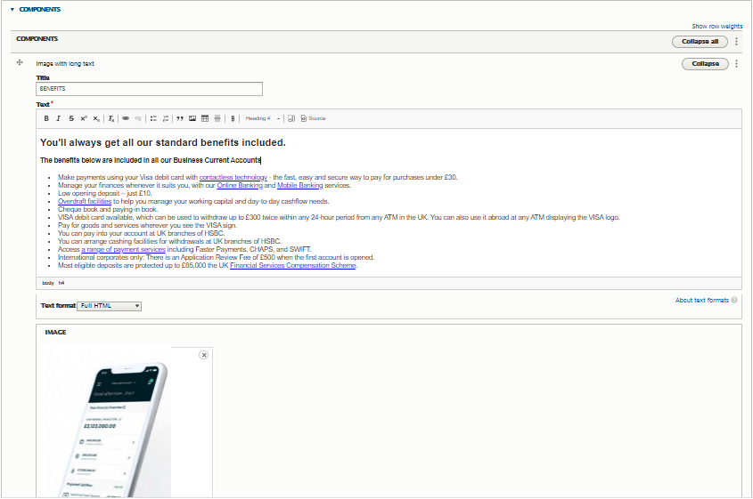

* For next 2 sections also you can select the component type as **“Title, Image with long text”** from the list it will populate with the fields for the same.
* Looking at the design we can select component types

Img3:

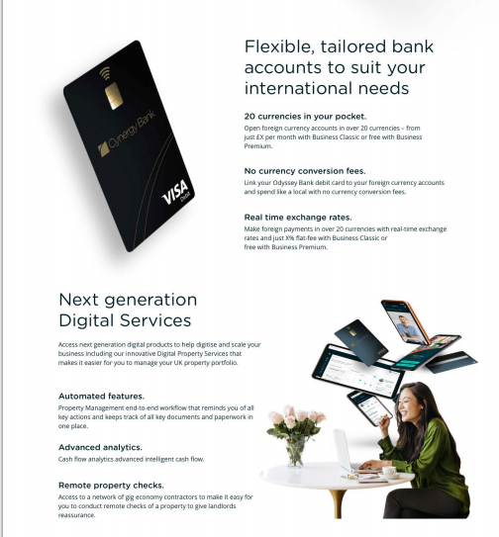

* Next component is “Apply Online”, once you select the component the fields for the same will populate as shown below:

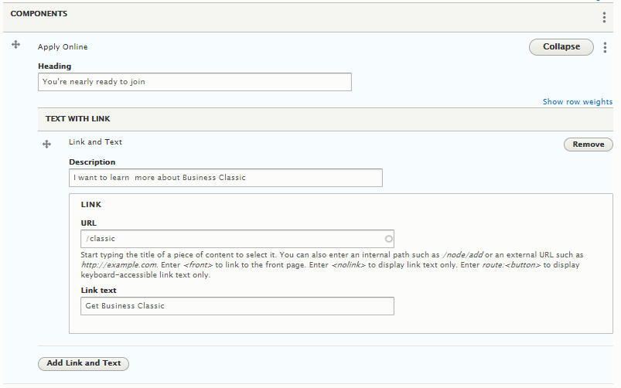

* On above image it’s shown form for one apply link option For adding one more apply button click on **“Add Link and Text option”**



#### Trusted Providers:

* Below Image is from the design page.

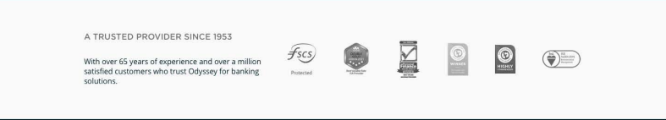

* The details of trusted provides is same as the landing page which can be referred here , just the display option is to be selected as **“Logo with Content”** as per the above design.
* Once all the details are filled click on the save button at the bottom of the screen, if you are an admin you can publish it directly else it will be saved as draft version which an admin can review and publish/archive later.

### Savings Account Suite Page

* Once logged in click on “**Content**” it will land you to the content listing page where you can see an option to **“Add content”**



* Add content option will take you to the list of content types page where you have to select the type of page you want to create, here for landing pages we’ll select **“Savings Account Suite Page”**

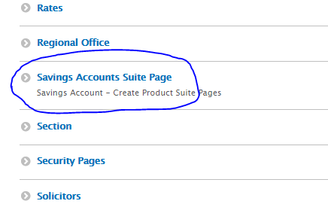

* On the content creation form you will have to fill all the details section by section

#### Banner:

* Banner section is same as home page, refer here

#### Compare Account(Compare our Savings Products)

* Image 1 below is from the design page; how it should look:

Img1: 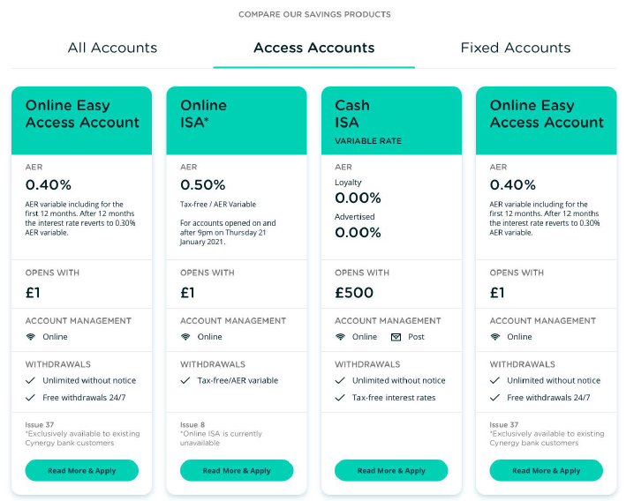

* The below images are from the content creation form for **“compare account section”** it shows fields for one product i.e. Cash ISA under Access Accounts.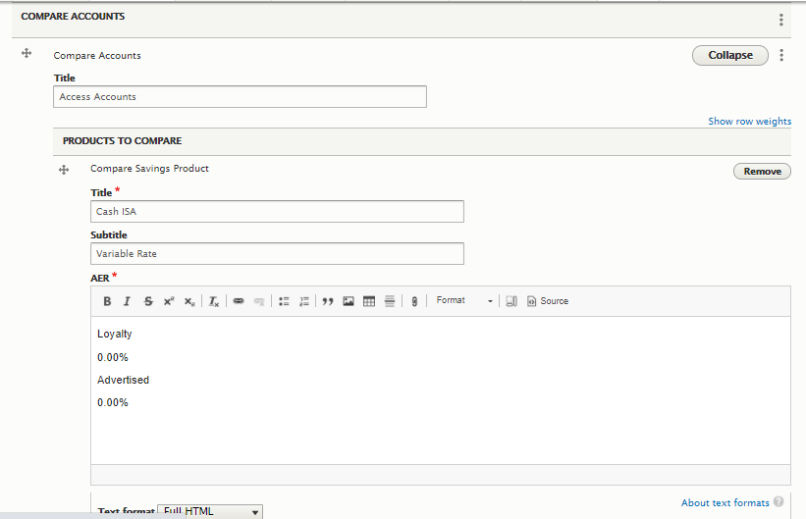

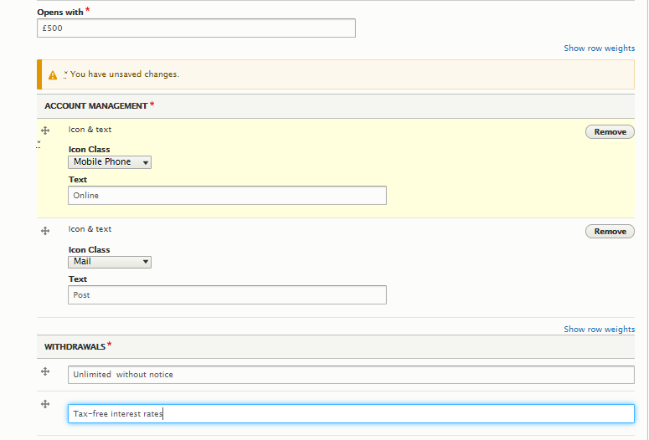

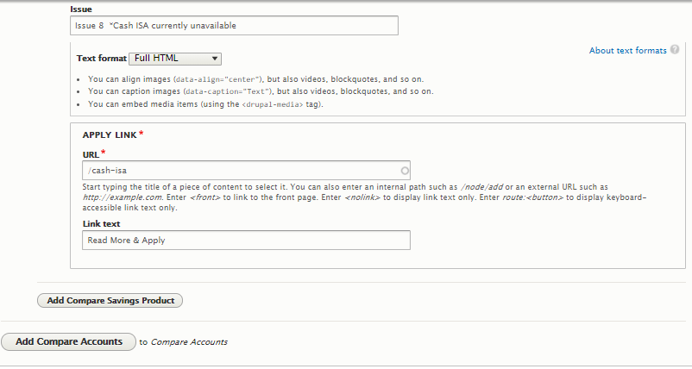

* All fields are text fields other than **“APPLY Link”** here we can specify the link text and URL for that product page.
* The Above example shows single product for Access Accounts comparison, we can add multiple products by clicking **on “Add Compare Saving Product**”button
* For Adding one more compare product item such as **Fixed Account product comparison** click on **“Add Compare Accounts”** button , it will populate same set of fields such as above.

#### Calculator:

* The Calculator part will be fetched from Equation by the Frontend , we are not saving the details in Drupal.

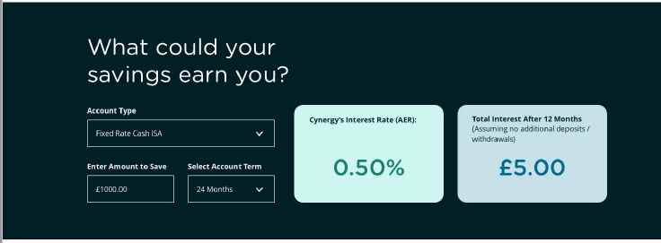

#### Trusted Providers:

* Below Image is from the design page.



* The details of trusted provides is same as the landing page which can be referred here , just the display option is to be selected as **“Logo Only”** as per the above design.

#### Awareness

* Image 1 below is from the **design page**; how it should look and image 2 is the **“Awareness”** section on the form.

Img1: 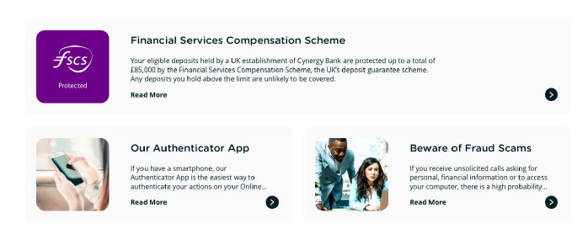

Img2: 

* The **Awareness** contents created here can be referenced, start typing the title of the content will auto populate to select.
* Once all the details are filled click on the save button at the bottom of the screen, if you are an admin you can publish it directly else it will be saved as draft version which an admin can review and publish/archive later.

### Finance Suit Page(Property Finance/Business Finance)

* Once logged in click on “**Content**” it will land you to the content listing page where you can see an option to **“Add content”**



* Add content option will take you to the list of content types page where you have to select the type of page you want to create, here for landing pages we’ll select **“Finance Suite Pages”**

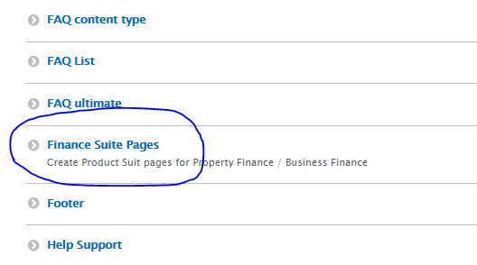

* On the content creation form you will have to fill all the details section by section

#### Banner:

* Banner section is same as home page, refer here

#### Components:

* We can have different types of component in this field as shown below, according to the design the component type can be selected

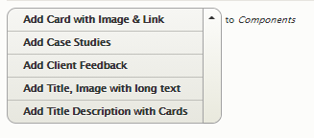

* For the sections like the below which has an image , title and some description text, we select **“Title, Image with long text”**

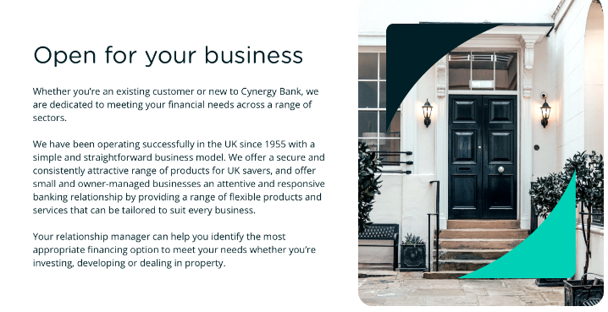

* The below image shows the section creation form on the **“components”** field:

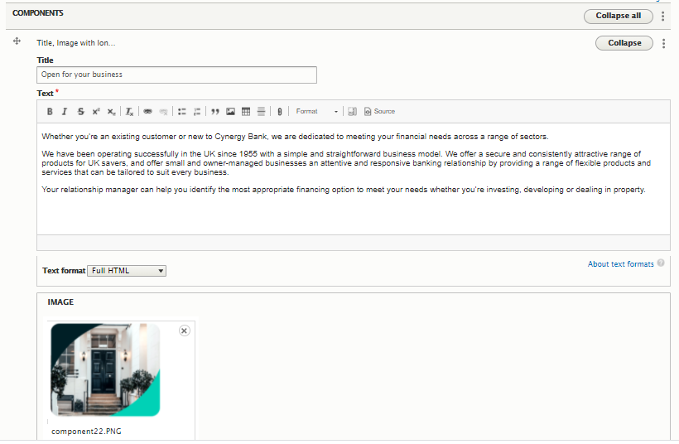

* For the sections like below where we have a title, an image description text and a link select **“Card with Media & Link”**

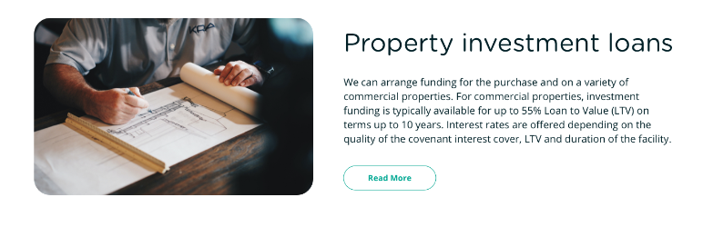

* The below image shows the section creation form on the **“components”** field:

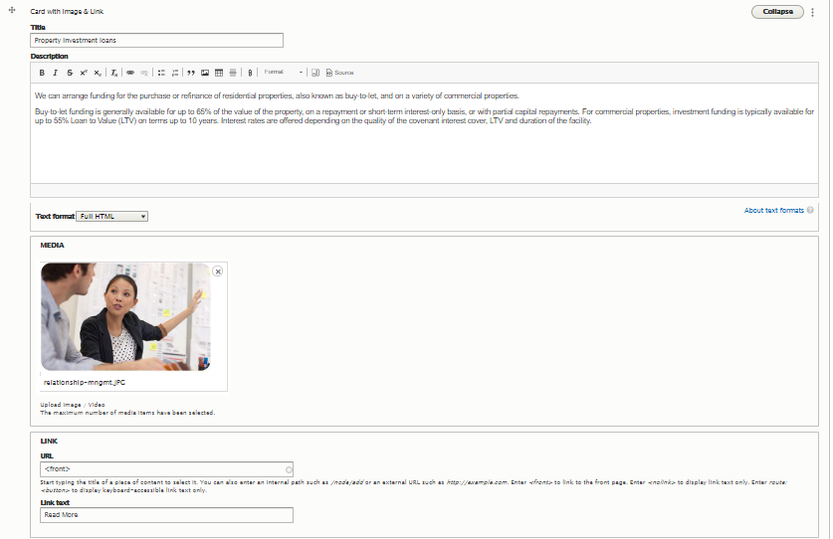

* For the sections like below where we must add some case studies, please select **“Case Studies”** type component

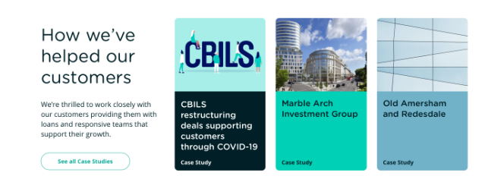

* The below image shows the section creation form on the **“components”** field:

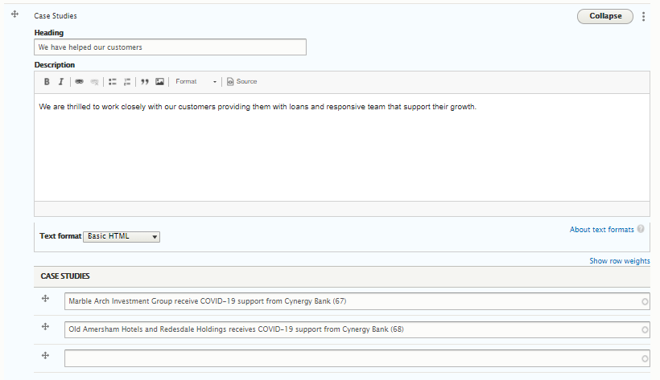

* **“Heading”** and “**Description”** are the text fields where you can enter the text contents, and the case studies created here can be referenced to the **“Case Studies”** field, start typing the title of the content it will auto populate.
* For the sections like below select **“Title Description with Cards”** component type

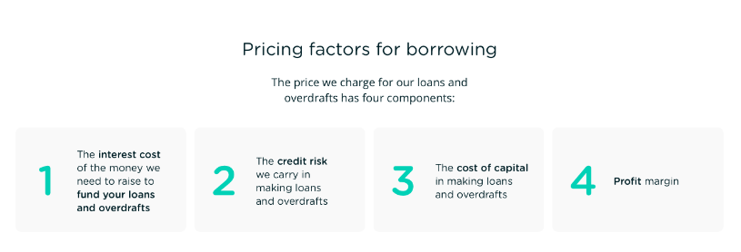

* Title and details fields are text fields for the 4 cards at the bottom of this section we have to select “Cards” here we have numerical value and some description in the design, so we select **“Number & Description”** to the Cards. Each card to be added one after another and the details is to be filled accordingly.

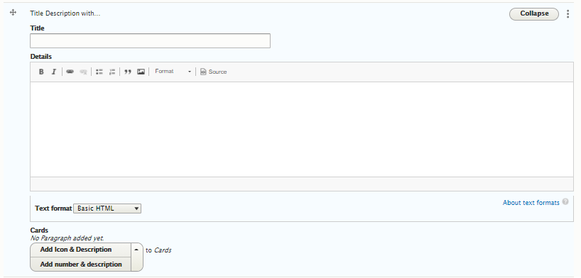

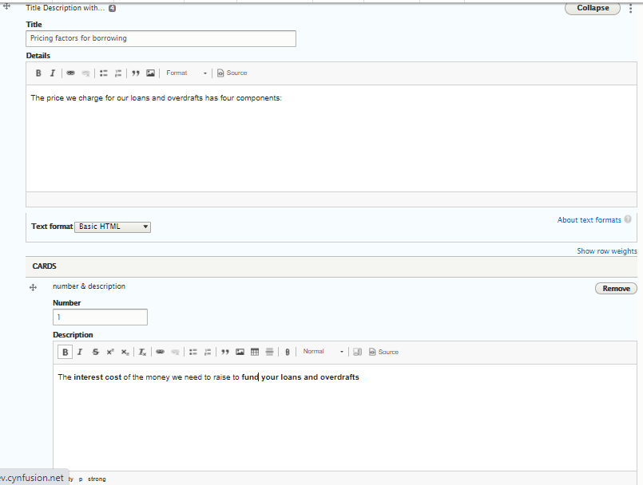

* The section below is for Client’s Feedback , select **“Client Feedback”** from the component list for this section:

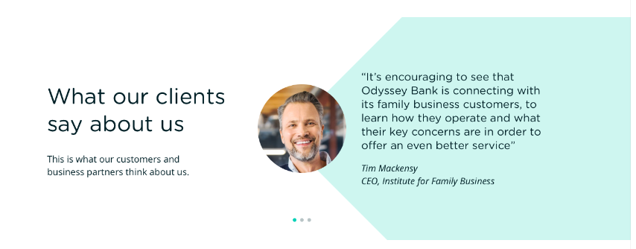

* **“Heading”** and “**Description”** shown below is the text appearing on the left hand side of the section.
* The “**Customer Feedback”** contents already created here can be referenced to the Customer Feedback field.

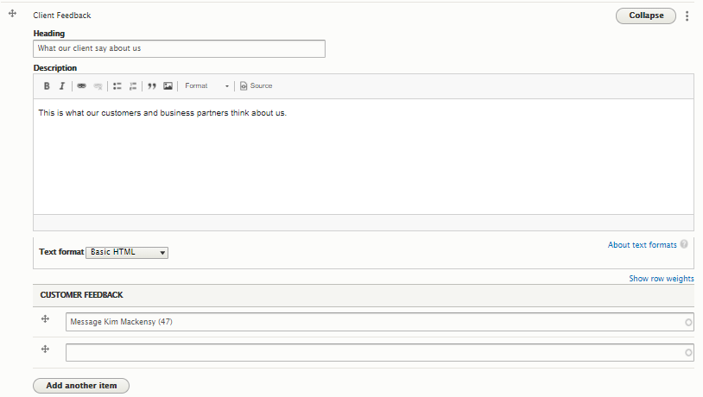

#### Trusted Providers:

* Image 1 below is from the **design page**; how it should look and image 2 is the **“Trusted Provider”** section on the form.

Img1: 

Img2: 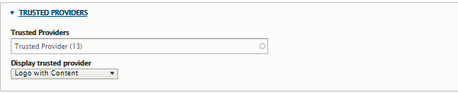

* We can have different style for displaying the “trusted providers” here in design we need **“Logo with Content”** that can be selected from the options on the field “**Display trusted provider**”
* The trusted provider content created here can be referenced in the field **“Trusted Providers”**

Once all the details are filled click on the save button at the bottom of the screen, if you are an admin you can publish it directly else it will be saved as draft version which an admin can review and publish/archive later.



## Product Pages

* Once logged in click on “**Content**” it will land you to the content listing page where you can see an option to **“Add content”**



* Add content option will take you to the list of content types page where you have to select the type of page you want to create, here for Product we’ll select **“Product Page”**

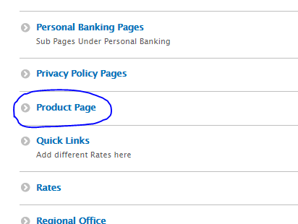

* On the content creation form you will have to fill all the details section by section

### Banner

* Banner section is same as home page, refer here

### Header Links

* Image 1 below is from the **design page**; how it should look and image 2 is the **“Header links”** section on the form.

Img1: 

Img2: 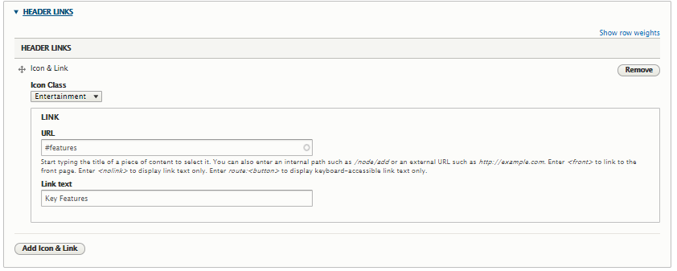

* The icon class need to be selected based on which the icons will appear on the frontend.
* Link text and link URL field for the quick links section , for each link you have to enter these 3 details.
* Click on “Add Icon & Link” button to add one more **“Header Link”** which will repeat the above fields.

### Components

* We can have different types of component in this field as shown below, according to the design the component type can be selected

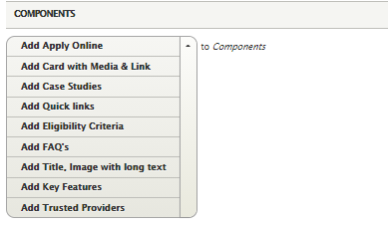

* For the sections like the below which has an image , title and some description text, we select **“Title, Image with long text”**



* The below image shows the section creation form on the **“components”** field:



* For the **“quick links”** section as shown below select the component type as “Quick links”

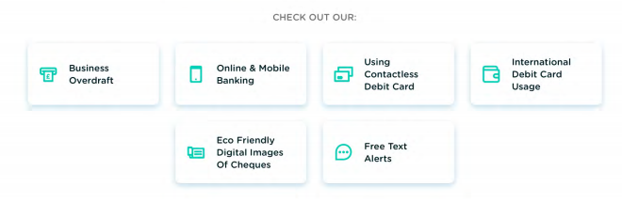

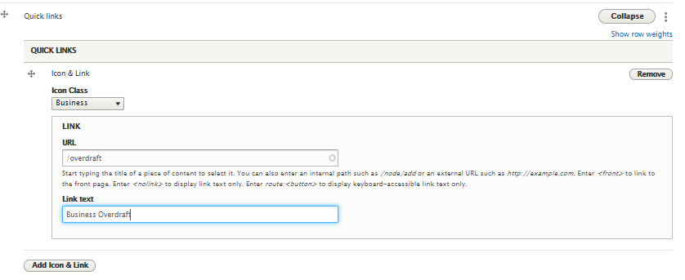

* + The icon class need to be selected based on which the icons will appear on the frontend, shown as below.
  + Link text and link URL field for the quick links section , for each card you have to enter these 3 details.
  + Click on “Add Icon & Link” button to add one more card which will repeat the above fields.
* For the sections like below where we have a title, an image description text and a link select **“Card with Media & Link”**



* For the sections like below select **“Title Description with Cards”** component type

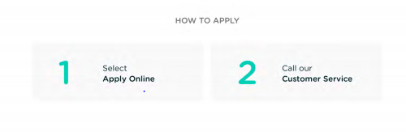

* + Title and details fields are optional text fields, we can leave blank if any is not required in design for the 2 cards at the bottom of this section we have to select “Cards” here we have numerical value and some description in the design, so we select **“Number & Description”** to the Cards. Each card to be added one after another and the details is to be filled accordingly.
* For the sections like below select **“Apply Online”** component type



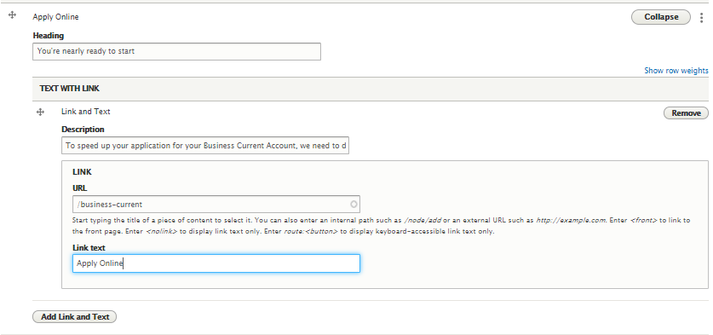

* Section line below is for FAQs**,** add **“FAQs”** type component

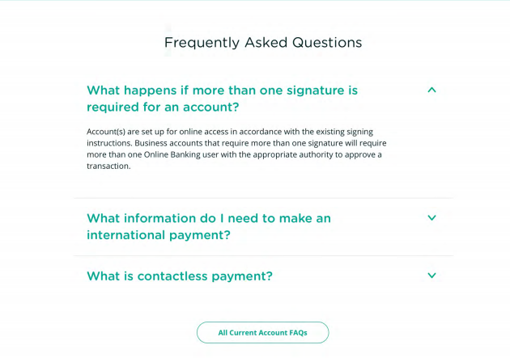

* + Heading is text field for the title of the section & FAQ contents already created here can be referenced to the “**FAQs”** field

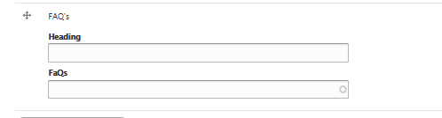

* For the Trusted Providers section like below please add **“Trusted Providers”** component type

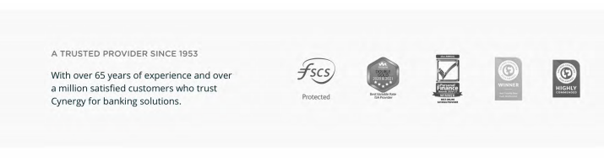

Img2: 

* + We can have different style for displaying the “trusted providers” here in design we need “Logo with Content” that can be selected from the options on the field “**Display trusted provider**”
  + The trusted provider content created here can be referenced in the field **“Trusted Providers”**
  + If the design is supposed to be the below select “Each Logo with Description” on the field “**Display trusted provider**”

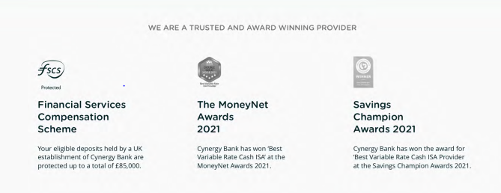

* For the Summary Box section like below please add **“Summary Box”** component type

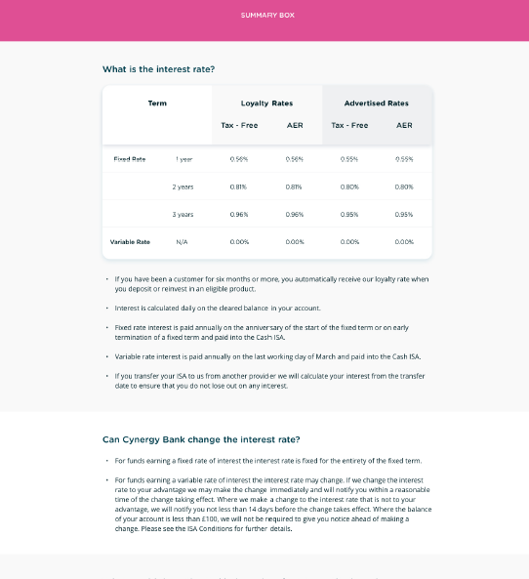

* We can have multiple “Title” and “Description” fields in Summary box, both are text fields.

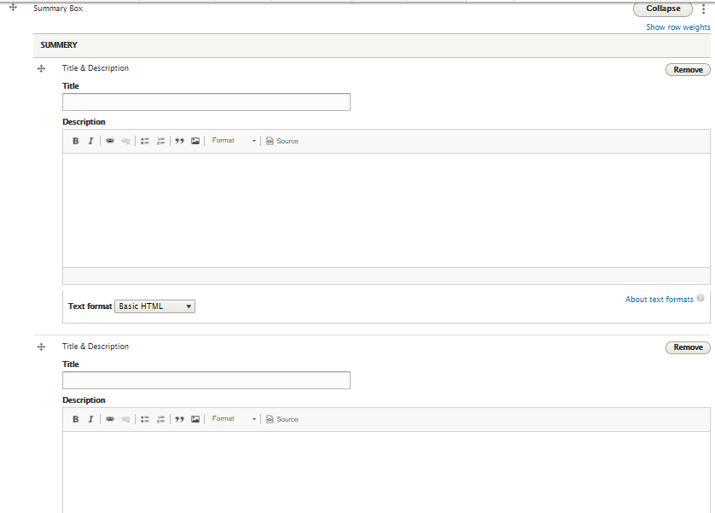

Once all the details are filled click on the save button at the bottom of the screen, if you are an admin you can publish it directly else it will be saved as draft version which an admin can review and publish/archive later.



## About Us Landing Page

* Once logged in click on “**Content**” it will land you to the content listing page where you can see an option to **“Add content”**



* Add content option will take you to the list of content types page where you have to select the type of page you want to create, here for landing pages we’ll select **“About Us Landing”**

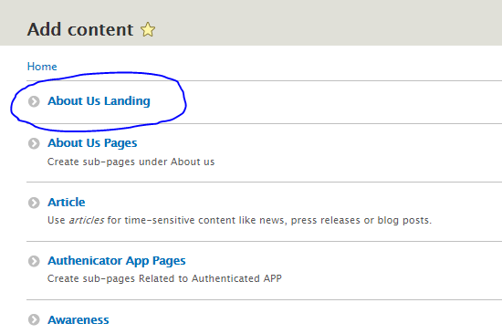

* On the content creation form you will have to fill all the details section by section

#### Banner

* Banner section is same as home page, refer here

#### Components

* We can have different types of component in this field as shown below, according to the design the component type can be selected

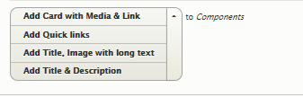

* For the **“quick links”** section as shown below select the component type as “Quick links”

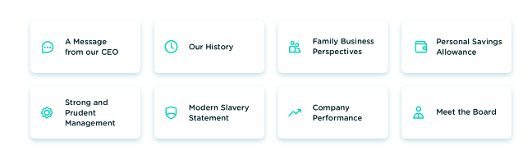

* The icon class need to be selected based on which the icons will appear on the frontend, shown as below.
* Link text and link URL field for the quick links section , for each card you have to enter these 3 details.
* Click on “Add Icon & Link” button to add one more card which will repeat the above fields.

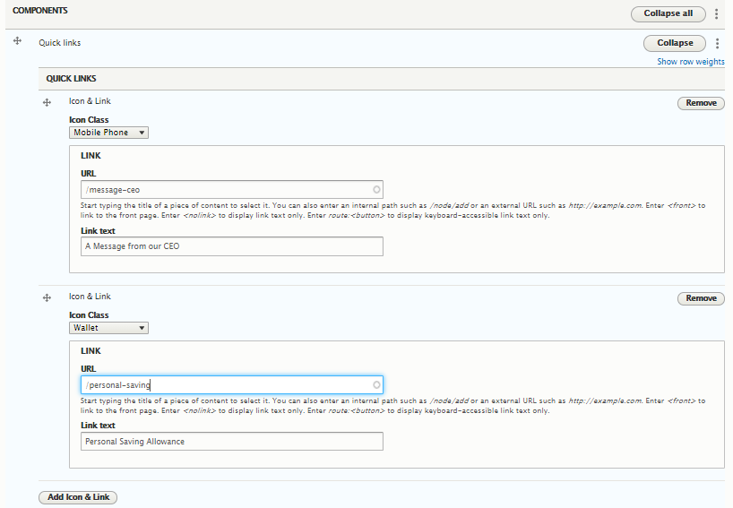

* For the sections like the below which has an image , title and some description text, we select **“Title, Image with long text”**

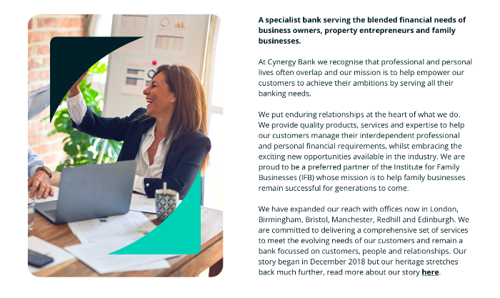

* The below image shows the section creation form on the **“components”** field:

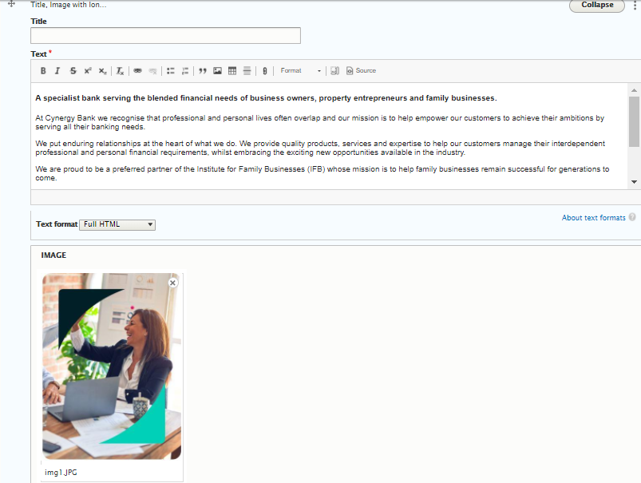

* Title field id optional, if the design doesn’t require title, we can leave the field blank.
* For the section like below which has a Title & Description please select **“Title & Description”**



* Both **“Title”** and **“Description”** are text fields:

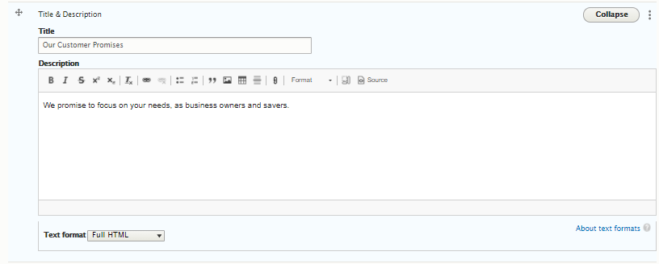

* For the section like below which has a title, description, a video file and a link we add **“Card with media & Link”** component type to the field

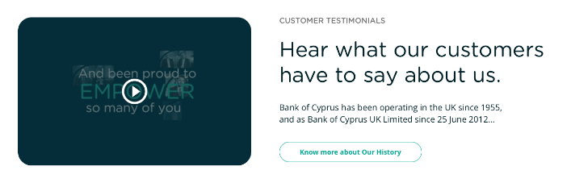

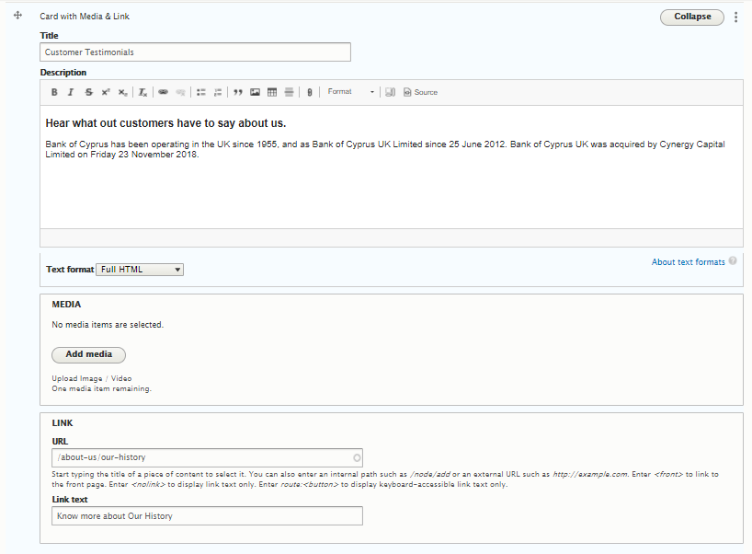

* **“Title”** & **“Description”** fields are text fields
* **“Media”** field supports both image and video(remote video URL & upload video files)
* **“Link URL” & “Link text”** is for the link field in the design

#### FAQs

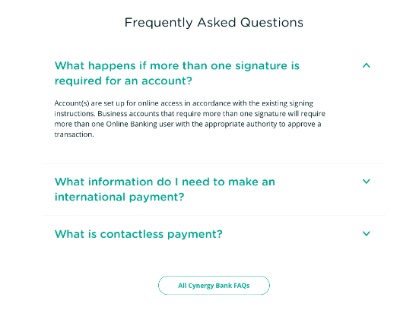

* FAQ contents already created here can be referenced to the “**FAQs”** field

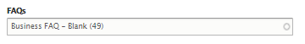

Once all the details are filled click on the save button at the bottom of the screen, if you are an admin you can publish it directly else it will be saved as draft version which an admin can review and publish/archive later.



### News & Articles

* Once logged in click on “**Content**” it will land you to the content listing page where you can see an option to **“Add content”**



* Add content option will take you to the list of content types page where you have to select the type of page you want to create, here for News & Articles we’ll select **“News and Articles”**

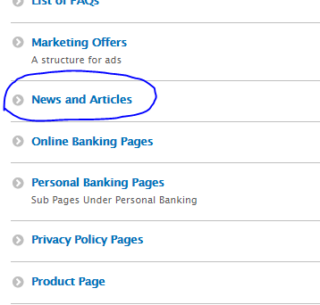

* On the content creation form you will have to fill all the details section by section

#### Type

* While creating the content one has to select its type from the list, it can either be a “News”, an “Article” or a “Case Study”

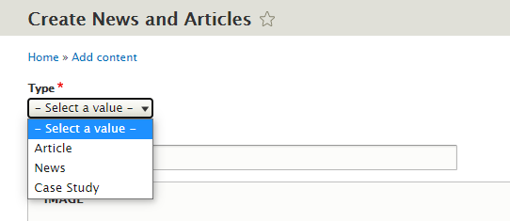

#### Title

* It’s the text field for the **“Title”** of the content



#### Image

* The image uploaded here appears as banner image on the detail page of the content and also on the “News and Articles” listing page, we can upload new image or select an existing image in the media library.

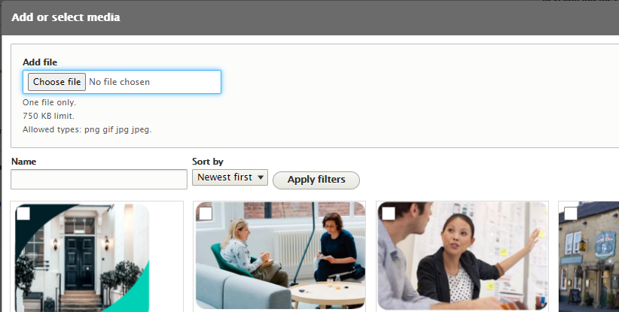

#### Display Image on News & Articles page

* As you can see in the below design screen, for some contents the images are visible and for some there is no image, this field helps you to select the same:

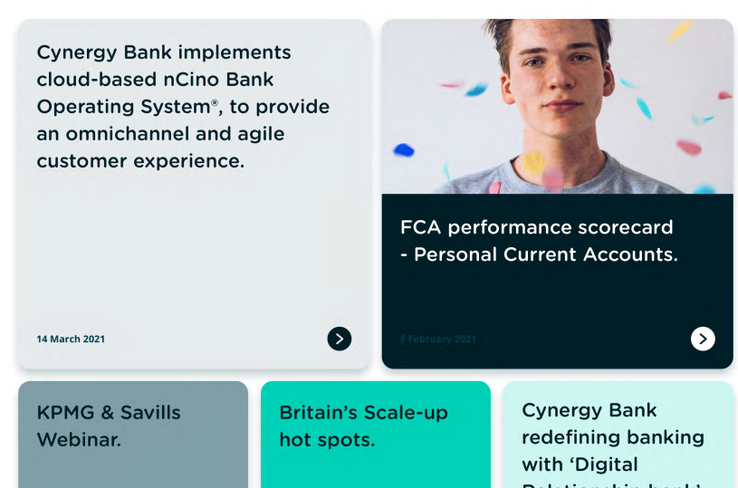

* If you want to display the image select “yes” else “No” in this field

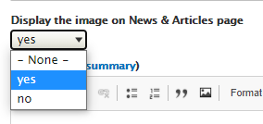

#### Content

* This is a text field, it contains the entire news content. You can insert inline images, files, table or any html attribute.

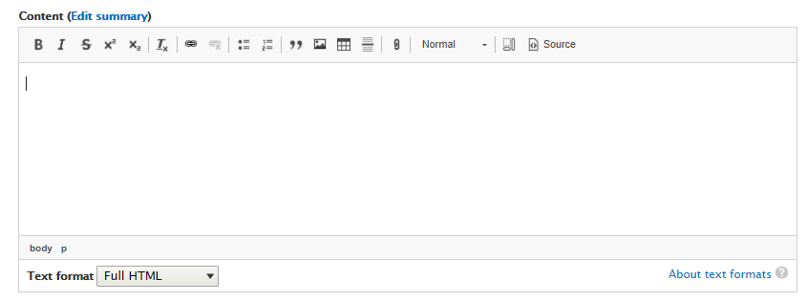

#### Snippet

* This is also a text field like content which contains the snippet text of the news

#### News Category

* Category to which the content belongs is to be selected here

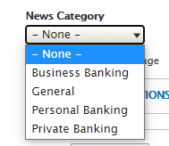

* The contents will get filtered with respect to this category selected on the front end as shown in the below design screen:

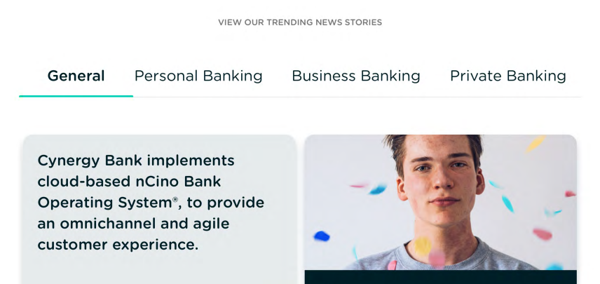

#### Feature on Home Page

* When this field is checked on any content, it will appear on the home page news & article section

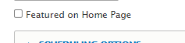

#### Schedule publishing & Unpublishing

* We can schedule the content to be published/unpublish to any future date and time, and the content will publish that time on cron run.

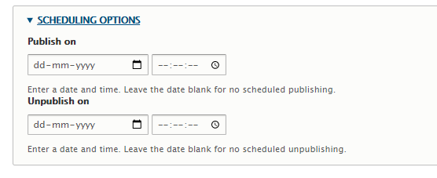

Once all the details are filled click on the save button at the bottom of the screen, if you are an admin you can publish it directly else it will be saved as draft version which an admin can review and publish/archive later.



## About Us Pages

* This content type is for the subpages under About Us page, we will move all About Us subpages from the existing website under this
* Once logged in click on “**Content**” it will land you to the content listing page where you can see an option to **“Add content”**



* Add content option will take you to the list of content types page where you have to select the type of page you want to create, here for About Us subpage contents we’ll select **“About Us Pages”**

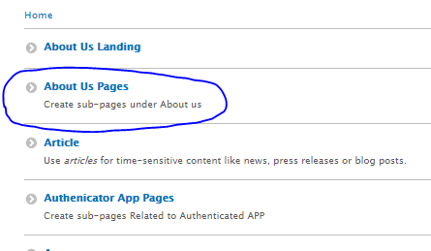

* On the content creation form you will have to fill all the details section by section

### Banner

* Banner section is same as home page, refer here

### Content

* This is a text field, it contains the entire page content. You can insert inline images, files, links, table or any html attribute.



## Authenticator App Pages

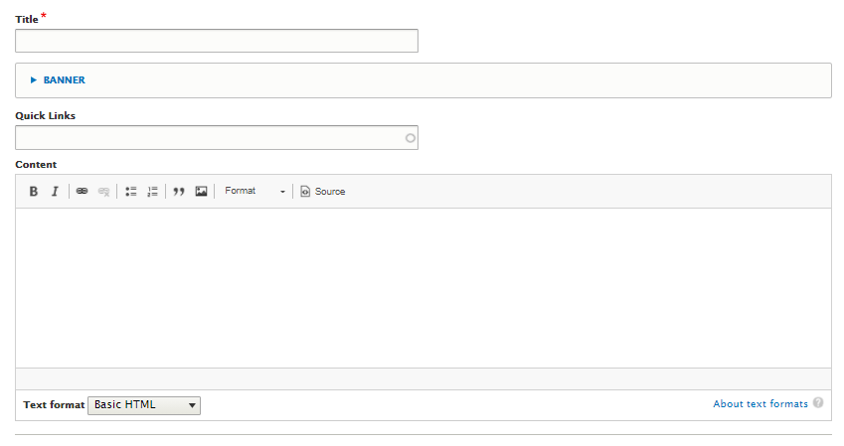

* All the pages under Authenticator App are to be created using this content type

### Title

It’s the content title, a text field

### Banner

Banner section is same as home page, refer here

### Quick Links

Quick link content created here can be referenced in this field, just start typing the title of the quick links content it will auto populate the contents available:

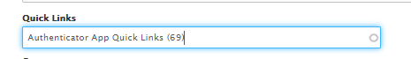

### Content

* This is a text field, it contains the entire page content. You can insert inline images, files, links, table or any html attribute.



We have same structure of all the subpages content types like above those are **“Business Banking Pages” , “Career Pages”, “Covid-19 Pages”, “Online Banking Pages”, “Security Pages” and “Solicitors”**

## Trusted Providers

* Once logged in click on “**Content**” it will land you to the content listing page where you can see an option to **“Add content”**



* Add content option will take you to the list of content types page where you have to select the type of page you want to create, here for Trusted Provider contents we’ll select **“Trusted Providers”**

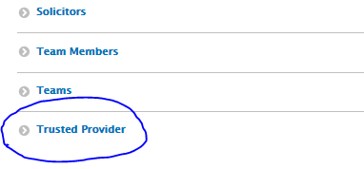

* On the content creation form you will have to fill all the details section by section
* “Title” and “Body” field are the text field which describes the **“Title” and “Details”** of the content
* We have 3 different types design of Trusted Providers:
  1. We have just the logos like this



* 1. We have “Title” “Description” and list of logos like this:

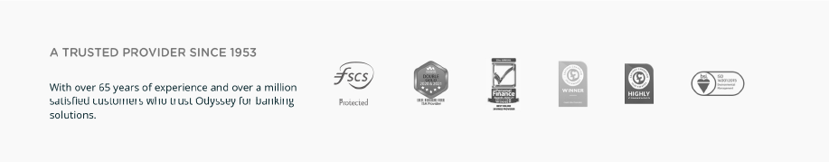

* 1. Lastly we have each logo with a title & Description like this:

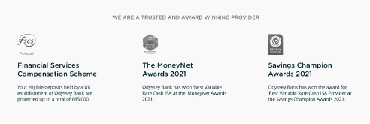

* For the first design front end will not display the **“Body”** content and to **“Logo & Link”** field please add “Logo & Link” type

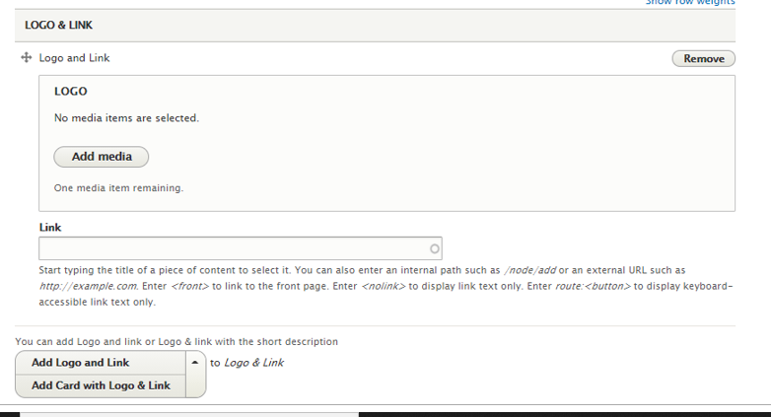

* For the 2nd design also to “Logo & Link”field please add **“Logo & Link”** type but here the body field text will be visible as description on the front-end
* For the 3rd design to “Logo & Link”field please add **“Card with Log & Link”,** it will populate with a “Logo” field a “Link” field and a “Description” field for each logo

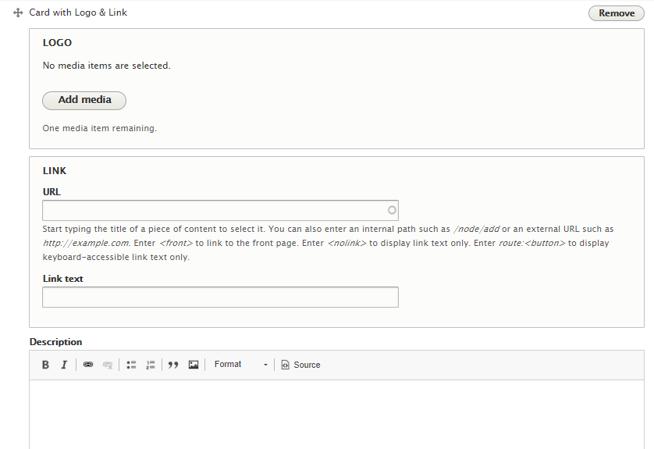

Once all the details are filled click on the save button at the bottom of the screen, if you are an admin you can publish it directly else it will be saved as draft version which an admin can review and publish/archive later.



## Customer Feedback

* Once logged in click on “**Content**” it will land you to the content listing page where you can see an option to **“Add content”**



* Add content option will take you to the list of content types page where you have to select the type of page you want to create, here for customer feedback contents we’ll select **“Customer Feedback”**

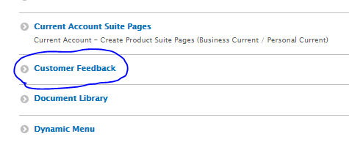

* On the content creation form you will have to fill all the details section by section

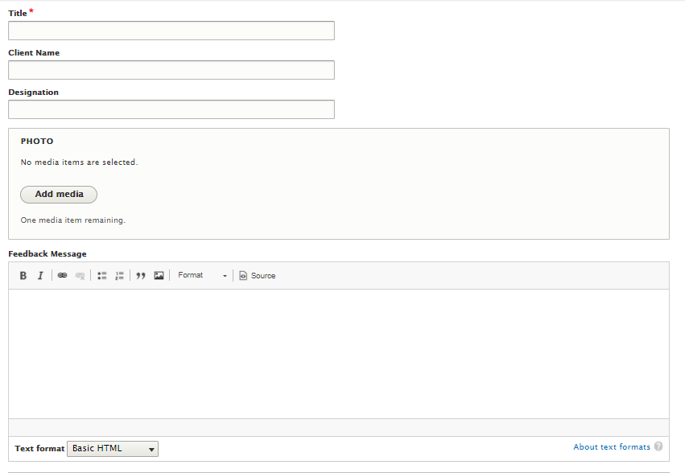

* “Title” field is for content title
* “Client Name” and “Designation” fields are for the clients whose feedback we are recording here
* We can upload client’s image here to the “Photo” field
* Lastly, we have the “Feedback Message” field which is a text field & can have the feedback message text from the client

## FAQs

* Once logged in click on “**Content**” it will land you to the content listing page where you can see an option to **“Add content”**



* Add content option will take you to the list of content types page where you have to select the type of page you want to create, here for FAQs contents we’ll select **“Corporate FAQ”**

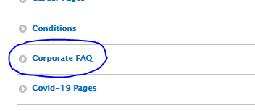

* On the content creation form you will have to fill all the details section by section

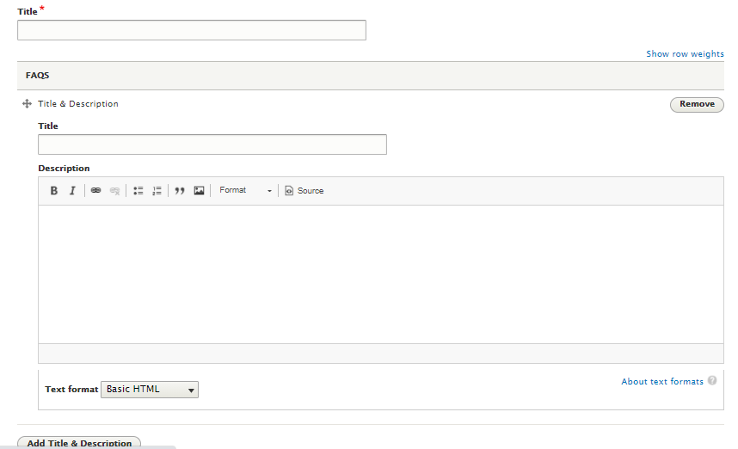

* Title field is a text field for the “Title” of the FAQ
* On **“FAQ”** field For each question & answer set we have **“Title & Description”** fields, to add each set click on the button “Add Title & Description” it will populate with the same set of fields.
* We have to categorize the FAQ set for which we have a “Category” field, start typing the category name It will auto populate with the list of categories, you can choose one from them.

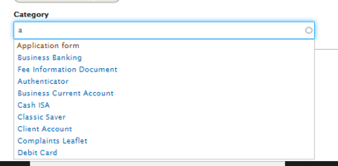

## Document Library

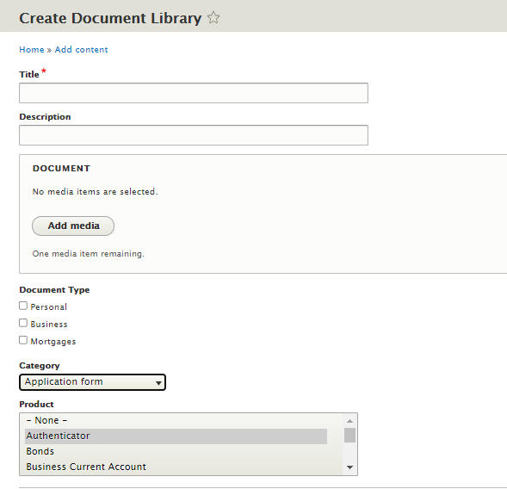

* “Title” & “Description” for the document details
* The document field allows to upload any new document or select from the existing one from the media library.
* “Document type” can be selected from the options given
* “Category” of the document can be selected from the select list
* The document is related to which product that can be selected under “Product” field

## Quick Links

* Purpose of this content type is, if multiple pages are supposed to show same quick links on their quick links section then instead of creating same links again & again we can create a quick links content with all the links and add reference to the content on all the pages required.
* For example on existing website **Covid-19**  page have some links on the left hand side of the page those links are same for all the pages which comes under Covid-19, in this scenario we can create a Covid-19 Quick link content and refer this on all the sub pages of Covid-19
* Once logged in click on “**Content**” it will land you to the content listing page where you can see an option to **“Add content”**



* Add content option will take you to the list of content types page where you have to select the type of page you want to create, here for Quick Links contents we’ll select **“Quick Links”**

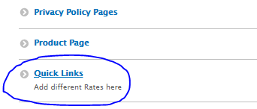

* On the content creation form you will have to fill all the details section by section

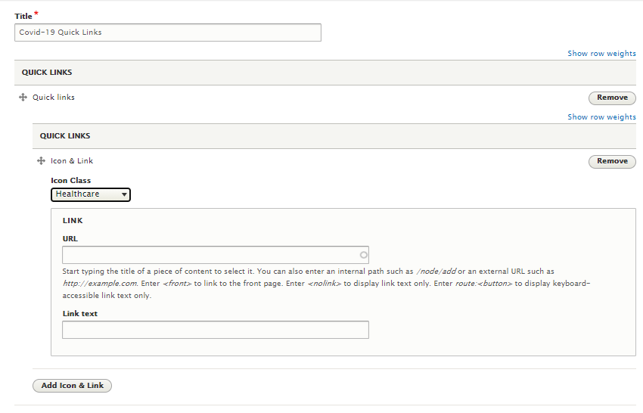

* “Title” is a text field for page title.
* The icon class need to be selected based on which the icons will appear on the frontend.
* Link text and link URL field for the quick links section , for each card you have to enter these 3 details.
* Click on “Add Icon & Link” button to add one more card which will repeat the above fields.

## Regional Office

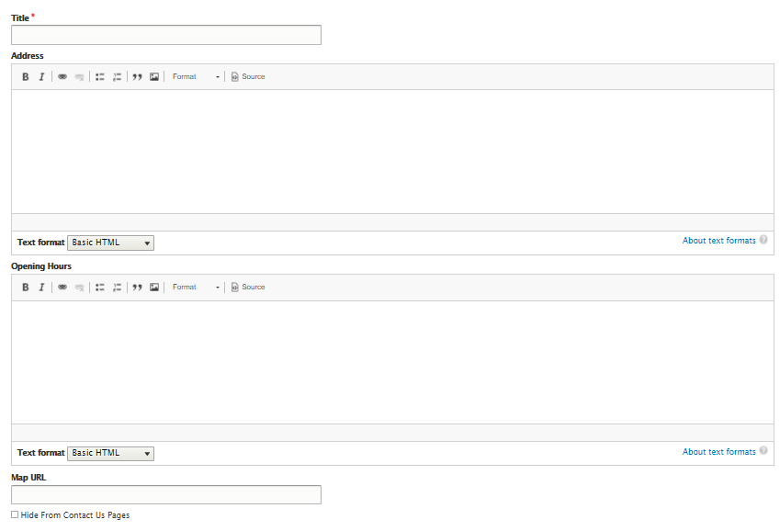

* “Title”, “Address”, “Opening Hours” and “Map URL” all the 4 fields are text fields respective details should go in there.
* If the checkbox “Hide from Contact Us Page” checked the content will be hidden on “Contact Us” Page

## Team Members

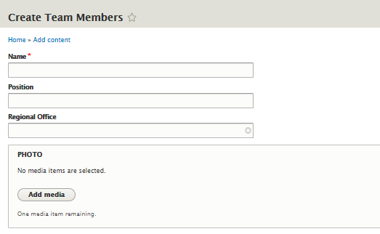

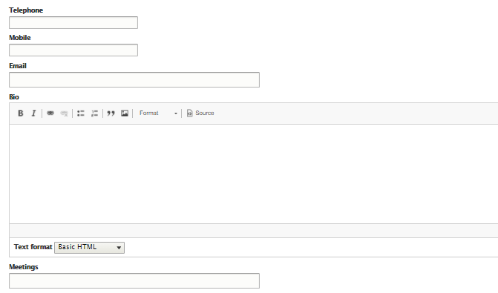

* “Name”, “Position” are the text fields respective details of the team member should go in there
* The regional office created here can be referenced to the **“Regional Office”** field
* Image of the team member can be uploaded on the **“Photo”** field
* Details of the **“Telephone”, “Mobile”, “Email”, “Bio” and “Meetings”** of the team member should be filled in the respective fields.

## Team

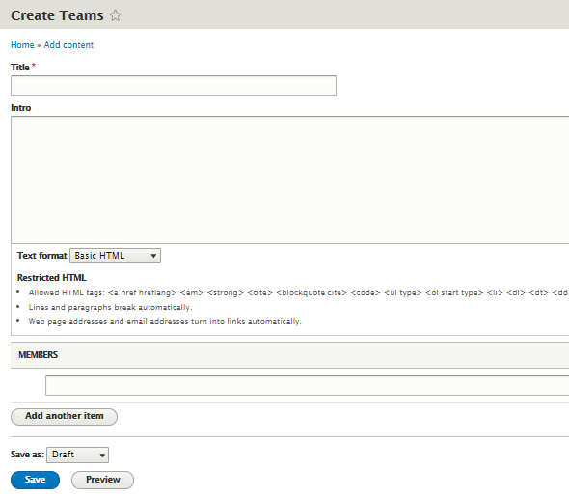

* **“Title” and “Intro”** for the team are both text fields respective details should go in there.
* Team members added here can be referenced in **“Members”** Field, start typing the name of the team member the available options will auto populate to select.
* To add multiple team members to the team click on **“Add another item”** button on the **“Members”** field

## Conditions

* Condition Type Contents are the contents which are now PDF documents, we need to copy those documents are contents
* These contents can be downloaded as PDF on the front end
* We just have **“Title” & “Content”** field both are text fields

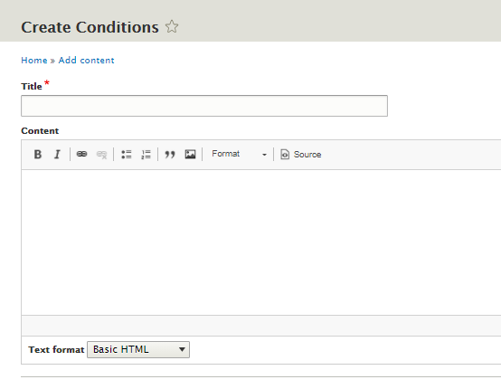

## Footer Section

* Footer section data can be added here
* As per the design it’s been separated to 3 parts; **First Block-Menu Links, Second Block-Description, Third Block- Links**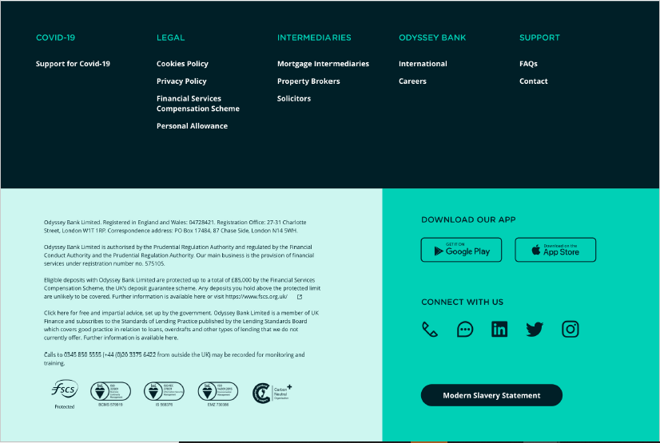

### First Block-Menu Links

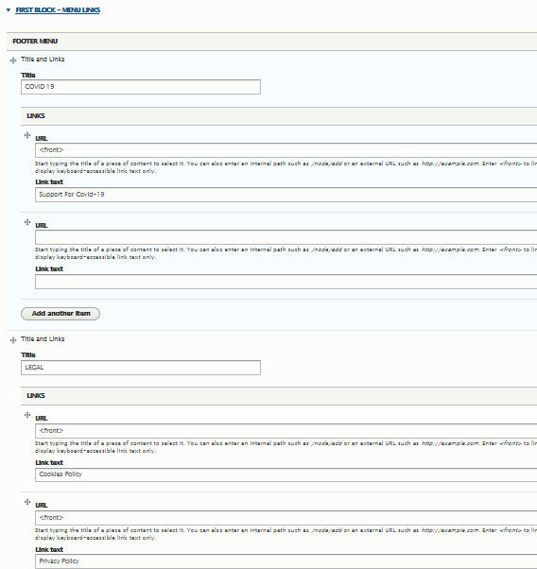

* For each column we’ll add **“Title and Links”** to the section under which we can add a single title and multiple Links as shown in the above image.

### Second Block – Description

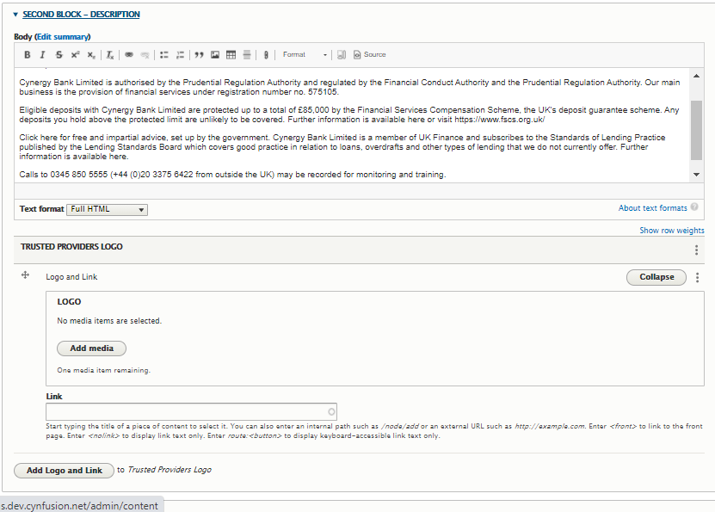

* “**Body**” field is the text field, the description should go in there
* “**Trusted Providers Logo**” we can add multiple logo and links by clicking “**Add Logo and Link**” button

### Third Block – Link

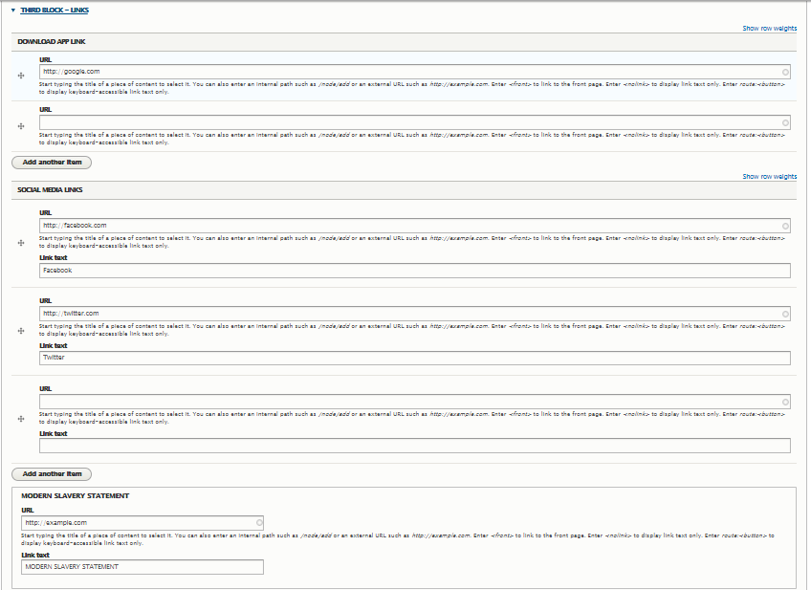

* **“Download App Link”** multiple links can be created by clicking on “Add another item” bottom of the field section
* **“Social Media Link”** Link text and URL can be filled in for the social media links, for adding multiple links click on “Add another item” button
* **“Modern Slavery Statement”** it’s a single link field, Link text & URL for modern slavery statement should go in there

# Creating Users

* You can create Users only if you are an Administrator.
* Once logged in click on the **“People”** section on top toolbar

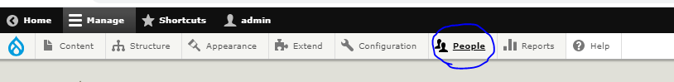

* It will take you to the User listing page where you can see all the Drupal users.
* Click on “Add User” Button if you wish to add a new User 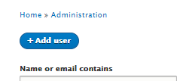
* **Username** and **Password** are the only mandetory fields

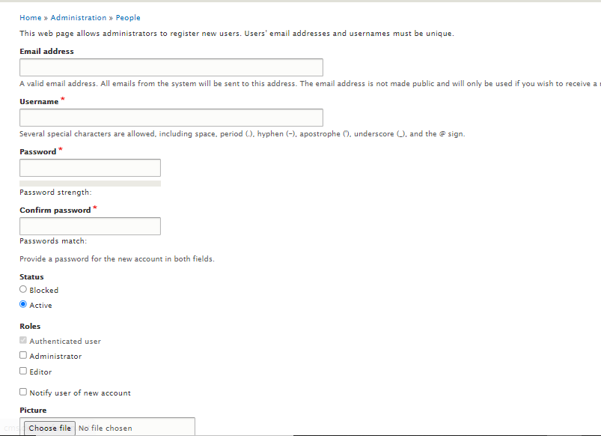

* By default the role of any new user will be **“Authenticated User” ,** they can’t create any content or do any activities in the CMS, they can only view the contents.
* If you wish to give them permission for more activities you can select the roles as **“Editor”** or **“Administrator”**